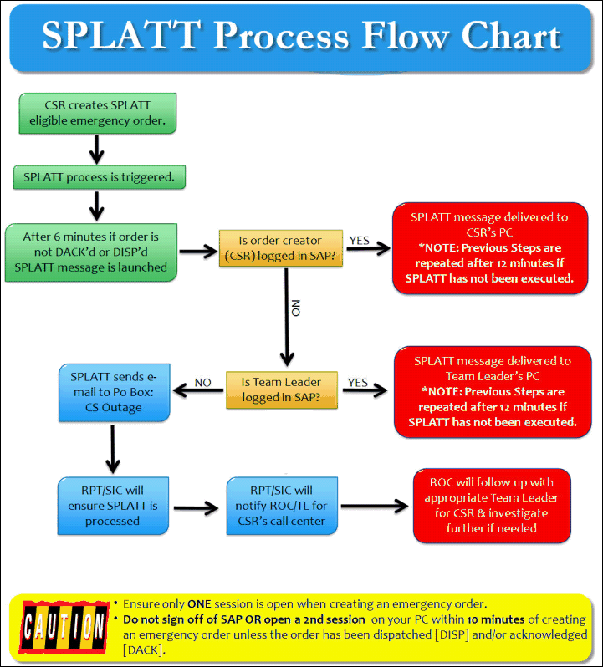

SPLATT Eligible Order Types

Keyword conditions that result in the creation of one of the electric emergency order types listed below will be included in the SPLATT process:
- Bld Fire in Progress
- Explosion
- Human Shock
- Electrocution
- Cnt w/Overhead Lines
- Emer 911 Disconnects
- Emergency Disconnect Electric
- Oil Spill/Trnf Leak
- Electric Meter Open Socket
- Sparking/Arc Serv Panel
- Open Padmount
- Life/Death
Keyword conditions that result in creation of one of the gas emergency order types listed below will be included in the SPLATT process:
- Investigate Gas Leak Inside
- Investigate Gas Leak Outside
- Investigate Leak T&S in Area

SPLATT Process

When you click on the scrolling message, this view displays:

There are 3 steps:
1) Click on the View Status button
2) Check the Mark Read box
3) Close

Click on VIEW STATUS button to determine if the order has been acknowledged [DACK] or dispatched [DISP]
- See NOTE below for important information for the VIEW STATUS button

NOTE: It's very important you click on View Status button to send message back to SAP confirming you received the SPLATT and are taking appropriate steps to confirm order status. If you just checked box for Mark As Read and then click CLOSE, this DOES NOT set the 'confirm' flag in SAP.
- If order shows DISP or DACK, check the MARK AS READ box and then click on CLOSE
- If order shows CNCL, check the MARK AS READ box and then click on CLOSE [SPLATT message will be sent even if order has been canceled]
- If order does NOT show CNCL, DISP, or DACK, call the appropriate dispatch area and, in addition to your name and call center, provide the COMPLETE ORDER number that is displayed on SPLATT message
Example of Model Statement When Calling Dispatch: "Hi, this is XXXX in the Alma Call Center. I'm calling to confirm you have received human shock order 387041284. If dispatcher is unable to locate by order number, please access order to obtain complete premise address, which you can give to the dispatcher.

